**TO LIST ALL THE LINKS**

**CODE**

**package** drop;

**import** org.openqa.selenium.By;

**import** org.openqa.selenium.WebDriver;

**import** org.openqa.selenium.WebElement;

**import** org.openqa.selenium.chrome.ChromeDriver;

**import** java.util.*;

**public** **class** List {

**private** **static** String[] *links* = **null**;

**private** **static** **int** *linksCount* = 0;

**public** **static** **void** main(String[] args) **throws** Exception {

WebDriver driver;

System.*setProperty*("webdriver.chrome.driver","C:\\ProgramFiles\\Java\\jdk1.8.0_131\\chromedriver.exe");

driver = **new** ChromeDriver();

driver.get("http://only-testing-blog.blogspot.in/2014/01/textbox.html");

java.util.List<WebElement> linksize = driver.findElements(By.*tagName*("a"));

*linksCount* = linksize.size();

System.***out***.println("Total no of links Available: "+*linksCount*);

*links*= **new** String[*linksCount*];

System.***out***.println("List of links Available: ");

// print all the links from webpage

**for**(**int** i=0;i<*linksCount*;i++)

{

*links*[i] = linksize.get(i).getAttribute("href");

System.***out***.println(linksize.get(i).getAttribute("href"));

}

Thread.*sleep*(3000);

}

}

**OUTPUT:**

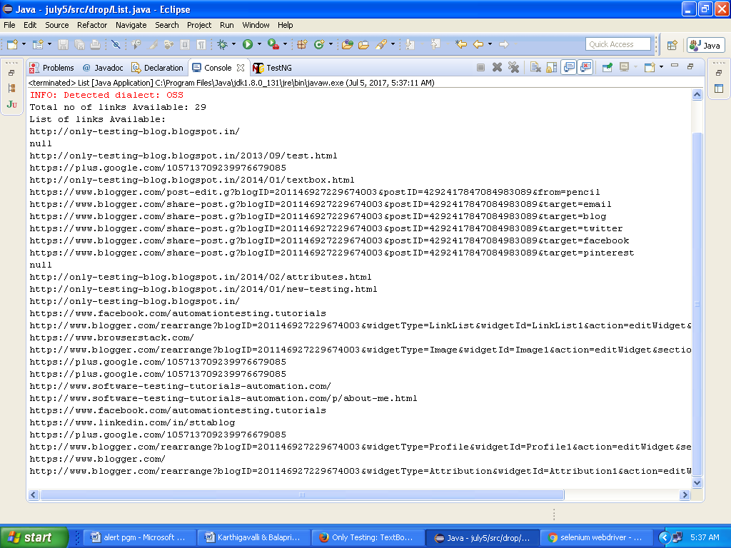

**TO LIST ALL THE DROPDOWNS**

**CODE**

**package** drop;

**import** java.util.List;

**import** org.openqa.selenium.By;

**import** org.openqa.selenium.WebDriver;

**import** org.openqa.selenium.WebElement;

**import** org.openqa.selenium.chrome.ChromeDriver;

**import** org.openqa.selenium.support.ui.Select;

**public** **class** DropDown {

**public** **static** **void** main(String[] args) **throws** InterruptedException{

System.*setProperty*("webdriver.chrome.driver","C:\\Program Files\\Java\\jdk1.8.0_131\\chromedriver.exe");

WebDriver driver = **new** ChromeDriver();

String baseUrl = "https://www.bing.com/account/general?ru=https%3a%2f%2fwww.bing.com%2f&FORM=O2HV65&id=language_section#language-section";

driver.get(baseUrl);

WebElement d = driver.findElement(By.*xpath*(".//*[@id='setlang']"));

d.click();//to first time click and open the drop down

Thread.*sleep*(3000);

Select auto = **new** Select(driver.findElement(By.*xpath*(".//*[@id='setlang']")));

List<WebElement> e = auto.getOptions();

**int** itemCount = e.size();

**for**(**int** l = 0; l < itemCount; l++)

{

System.***out***.println(e.get(l).getText());

}

}}

**OUTPUT:**

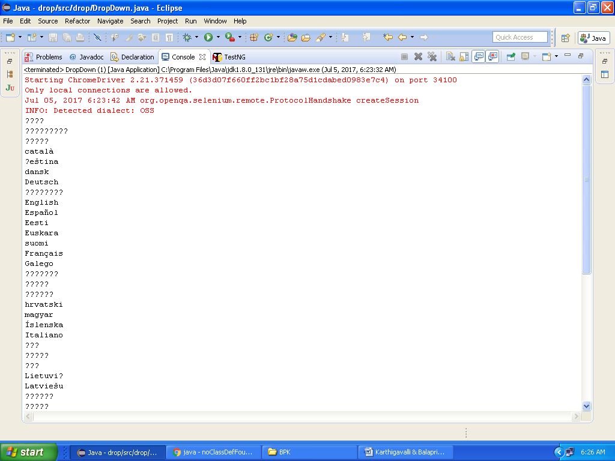

**TO AUTOSELECT THE DROPDOWN**

**CODE**

**package** drop;

**import** java.util.List;

**import** java.util.concurrent.TimeUnit;

**import** org.openqa.selenium.By;

**import** org.openqa.selenium.WebDriver;

**import** org.openqa.selenium.WebElement;

**import** org.openqa.selenium.chrome.ChromeDriver;

**import** org.openqa.selenium.support.ui.Select;

**public** **class** DropDown {

**public** **static** **void** main(String[] args) **throws** Exception {

WebDriver driver;

System.*setProperty*("webdriver.chrome.driver","C:\\Program Files\\Java\\jdk1.8.0_131\\chromedriver.exe");

driver = **new** ChromeDriver();

driver.manage().window().maximize();

driver.manage().timeouts().implicitlyWait(5, TimeUnit.***SECONDS***);

String baseUrl = " http://only-testing-blog.blogspot.in/2014/01/textbox.html";

driver.get(baseUrl);

WebElement d = driver.findElement(By.*xpath*(".//*[@id='Carlist']”);

d.click();

Select auto = **new** Select(driver.findElement(By.*xpath(“*//*[@id='Carlist']")));

auto.selectByVisibleText("50");

List<WebElement> e = auto.getOptions();

**int** itemCount = e.size();

**for**(**int** l = 0; l < itemCount; l++)

{

System.***out***.println(e.get(l).getText());

}

}}

**OUTPUT:**

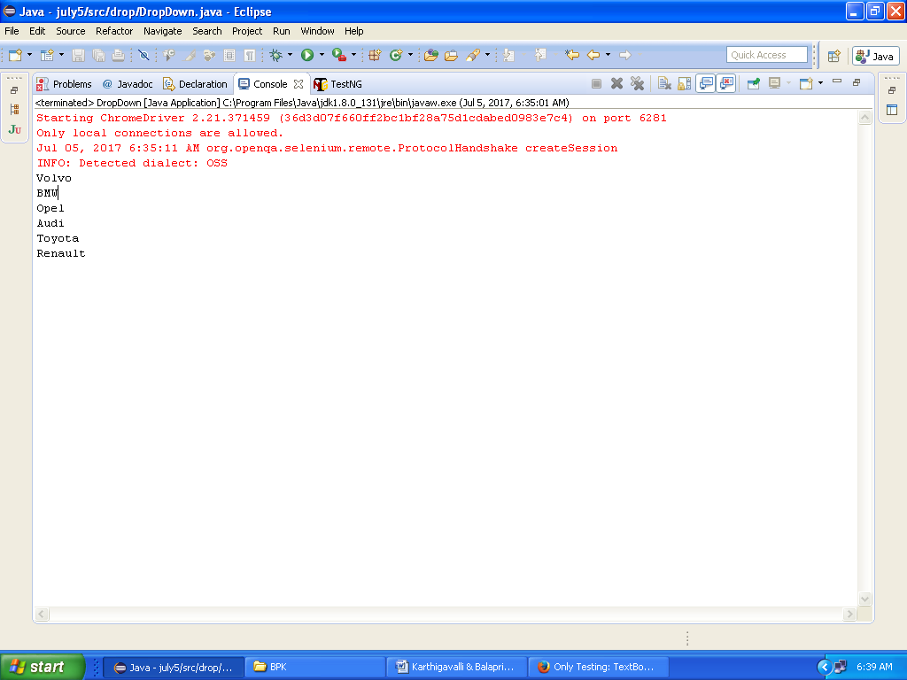

**TO PRINT SHOW ME ALERT MESSAGE**

**CODE:**

**package** drop;

**import** java.util.concurrent.TimeUnit;

**import** org.openqa.selenium.Alert;

**import** org.openqa.selenium.By;

**import** org.openqa.selenium.WebDriver;

**import** org.openqa.selenium.chrome.ChromeDriver;

**public** **class** Prompt

{

**public** **static** **void** main(String[] args) **throws** Exception {

System.*setProperty*("webdriver.chrome.driver","C:\\ProgramFiles\\Java\\jdk1.8.0_131\\chromedriver.exe");

WebDriver driver = **new** ChromeDriver();

driver.manage().window().maximize();

driver.manage().timeouts().implicitlyWait(5, TimeUnit.***SECONDS***);

driver.get("http://only-testing-blog.blogspot.in/2014/01/textbox.html");

driver.findElement(By.*xpath*(".//*[@id='postbody4292417847084983089']/div[1]/input")).click();

Alert A3 = driver.switchTo().alert();

String Alert = A3.getText();

A3.sendKeys("");

System.***out***.println(Alert);

Thread.*sleep*(2000);

}

}

**OUTPUT:**

